 | THE HELLENIC LINK, Inc.  ΕΛΛΗΝΙΚΟΣ ΣΥΝΔΕΣΜΟΣ  Member Update- BULLETIN  Editorial Committee: Ahilleas Adamantiades, Evangelia Georgoulea,  Maria-Eleftheria Giatrakou, Dean C. Lomis, Katherine Efthymiatou-Stabile  Contributing Editor: Dimitrios Oreopoulos Acting Editor: Constantine Efthymiou  No. 80, August 2009

Advisory Committee: Changes in Task Scheduled for Summer 2009
As was reported in the Bulletin #76 ( February 2009), the BOD activated its Advisory Committee (AC) for the expressed purpose of finding ways to advance certain focused objectives of our Association: e.g., the establishment of interactive communication and cooperation with other cultural and educational communities sharing our vision for the future of the Hellenic language and ethnic heritage in North America. Before the AC could set in motion the orderly study of the points designated by the Board, a significant development came to fore, requiring a change in the announced plan. The HL Board was informed with pleasure that topics included in the AC summer work would be key themes in a national Forum and Conference being organized by the American Foundation for the Greek Language and Culture (AFGLC) for early 2010. Moreover, it was suggested by AFGLC that the HL actively participate in this Forum and Conference with relevant position papers for which members of the Advisory Council on Hellenic Education have had already carried out significant work under its auspices.
Since several of these Council members had already agreed to support the AC summer-task assignment, it was decided that in order to avoid a conflict to postpone the AC project until the findings of the AFGLC Conference become known; in addition, emphasis was placed on the educational work of the Advisory Council to be presented, as suggested, at the AFGLC Conference by the same HL scholars-members. At the time of this writing, a number of our colleagues in the HL Advisory Council are energetically engaged in the preparation of presentations for this Conference, which according to received information will be held on the campus of the University of South Florida in Tampa. Further information and details of the Conference Program will be forthcoming from the AFGLC. Naturally, the Bulletin will keep the HL members and its readers thoroughly informed on the significance of the Conference and the nature and content of scholarly contributions to it by participants.
Redesigning and Re-Programming of the Hellenic Link Web Site
The visitors of our Web Site will soon witness a new look of improvement in its functionality.
The Board of Directors has decided to proceed to this improvement after seven years in operation
of the existing system, which has served rather well the communication and outreach efforts of our Association. An increasing tempo and volume of demands on our Site, however, coupled with its now obsolescent technology resulting in higher maintenance costs, make it necessary to improve it.
After comprehensive evaluation, which included foreseeable needs in the Hellenic Education sector, it was decided that a more flexible and capable Web system was needed to address effectively present and future needs.

Thus, technical improvements currently processed into our Site have been selected for a simplified and less costly maintenance, employing contemporary programming tools, and for an expanded ability to more easily present lengthy articles, even including such written in Greek. The switch to the redesigned Site will allow a broad array of options to be effected and utilized in stages; they include a flexible recall of current and archived past articles in chronological order, and a significantly improved calendar page for forthcoming-event announcements. The new Site will link with other interactive Web Sites; it will be also automated for an e-mail subscription and e-mail “blasts.” These options are being installed at the present time. Later, a Language and Culture Section will be added as a bi-level content-categorization system that will be searchable. It will enable the Advisory Council on Hellenic Education to offer to its users, students, educators, etc, a nearly unlimited bank of educational data, arranged in categories and subcategories.

It is obvious that the explained improvements, required by our Association in its emerging role as a Cultural and Educational Resource for the Omogeneia, can be only realized at a price. Avowedly, the budget approved for their funding could not be hinged on the annual HL membership dues, as they are inadequate for the task. Special donations are a necessity. Accordingly, members of the HL BOD are leading a voluntary collection of donations needed.

We are authorized to ask our membership and readership at large for an affordable donation,
which will enable the HL to make good a needed progress in its operation. Please write your tax- deductible check in the name of Hellenic Link, Inc., specifying the purpose: “Redesign of HL Web Site,” and send it to the address: The Hellenic Link, Inc., Suite No. 278, 38-11 Ditmars Blvd, Astoria,
New York 11105

We hope that with the well-established tradition of willful small sacrifices, which historically have amplified the effect of collaborative HL projects, the beneficial effects of a redesigned Web Site will
become evident soon and will be widely felt. Projected inauguration of the redesigned Site is Fall 2009.

Full Classics Return Gradually to Long Island School
With the enthusiastic encouragement of parents, teachers, and the Advisory Council of the Hellenic Link, students at the Syosset High School in Long Island submitted a petition and were granted approval to form
a Classic Languages (Greek and Latin) Club to promote the study and appreciation of the two world civilizations, Greek and Roman, which provided the foundations for our modern Western Culture.

Review of the HL by-Laws for Possible Revision
In the past year, the Board of Directors of the Hellenic Link, Inc. turned its attention, inter alia, to certain issues related to its administrative structure and operation. Specifically, the question arose whether certain articles of the By-Laws as originally expressed continue to be fully applicable under current conditions,
and whether changed circumstances requite amendment. To address the issue, the Board asked one of its Members, Dr. Dimitri Staikos, to focus an analysis of certain Articles, make an evaluation, and express
his opinion on the need for amendments. Dr. Staikos did carry out the requested review and presented
his findings in the following report:

“I have reviewed the HL Bylaws and specifically those pertaining to Membership (Article 3)
relating to:
1. Membership dues
2. Requirements for membership, and
3. Matters pertaining to "Affiliated Sections" or "Chapters of HL," and specifically to "HL
Section in Greece."
a. There is no question; an organization should have sufficient income (particularly from payment
of dues) so as to be active and productive in its efforts to implement its goals, etc. Increasing
membership dues is easy to propose but may not be easy to accomplish - particularly in the
economic hard times we are facing at present.
The proposed changes (BOD meeting of 12/17/06) appear to me quite difficult to accomplish.
My recommendation to the BOD at this time is to halve the differences. (Editor’s Note: that is, instead of raising the original full membership dues from $30 to $50, limit the increase to $40).
Regarding "financial potentiating" of the HL Inc., I would propose additional sources:
Donations or grants from corporations or businesses in general as well as from those who have a
direct connection, e.g. Greek establishments who support and would be eager to promote the
goals and ideals of the HL. Such donors would be duly recognized by 'donor plaques' or
'certificates of appreciation'.
b. Yes, provision should be made in the Article pertaining to requirements for membership so as not
to restrict membership to those (3.1, b) "having educational level consistent with the cultural and
scientific character of the HL".
There is no doubt that many others would support and promote the goals of the HL, Inc., be it in
educational, or scientific, or technological or other fields - all goals, however, having the ultimate
purpose to expand and enhance Hellenic Heritage and Values, thus "enlarging the visible borders
of the land of the Hellenes".
c. Regarding the HL Section in Greece
Obviously, any formal statements regarding this Section's existence and specifically its existence
as "a Section of the HL, Inc." have to be written in such a way as to be appropriate and allowable
by the Greek authorities. I will suggest that any monetary transfers ('dues') payable to HL, Inc.
be on a voluntary as well as on an individual basis.
Our association (I mean HL’s association)) with all those distinguished persons we have in
Greece, and their willingness to join and to support HL's overall purpose, is more important
than a few hundred dollars worth of dues.
Regarding the language to be used
Any documents required to define goals, purpose, association, etc. can be easily made in Greek
and in English. We could modify the Bylaws that pertain to "HL Section in Greece" and
include any language or restrictions imposed by the Greek authorities as I mentioned earlier.
These are only my personal thoughts on the subjects, and I would welcome BOD's action for the
best interest of its members.
Dimitri Staikos, Ph.D.
Member of the Board of Directors.
Hellenic Link, Inc.

With due consideration of this review, the Board has decided to refer the matter to the General Assembly. The membership, in a referendum, will be asked soon to decide which of the Articles of the By-Laws should be amended, and to specify relevant language for them. In the meantime, members in good standing are invited to participate in the discussion and express their views.

Genocide Revisionism

We have received the following letter from one of our members, sent by him in response to publication of a major news organization that took the stand in support of a colossal cultural issue of our time-public attitude towards Genocide. We reprint it for the information and guidance of our members and readers.

Eric E. Schmidt, Ph.D.
Chairman & Chief Executive Officer
Google, Inc.

Dear Dr. Schmidt:

Please accept my commendation for your and your company's stand against
revisionism of the Armenian Genocide historical fact. As a university educator, now retired, society must never accept the revision of history to satisfy the illicit satisfaction of special interests.

Speaking not as a descendant of Armenian parentage -- of which I am not-- but as a member of the global village, if we were to revise history for the pleasure of the few, then truth would become a mercantilist commodity to be traded for whatever advantage reasons. Such tactic would make any act of "man's inhumanity to man" irrelevant, and the motto of "never again" a comical falsehood.

Sincerely yours,

Dean C. Lomis, Ph.D.
715 Chrysler Avenue
Newark, DE 19711-4957

Hellenic Book Club Selection of the Month

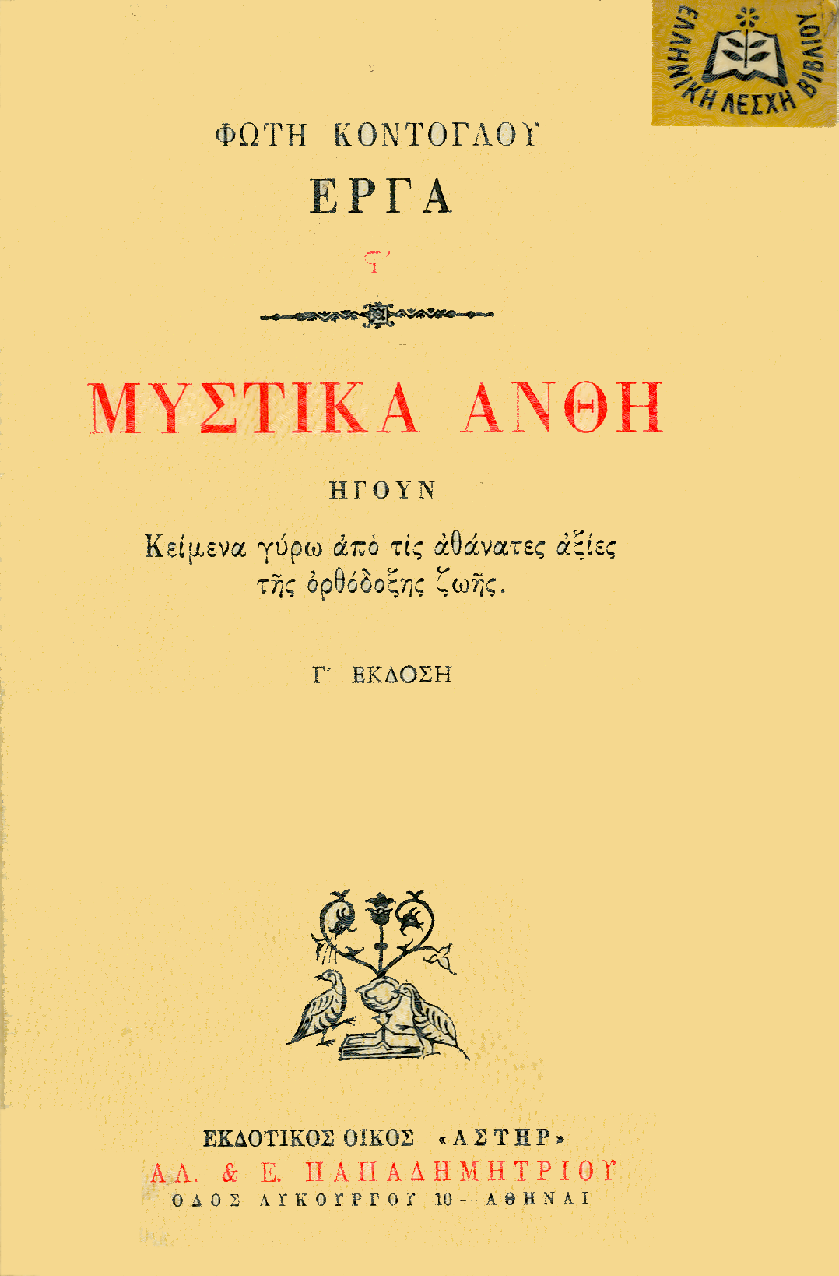 B8Θ752* "Secret flowers"
Texts from the immortal values of orthodox life
Fotis Kontoglou
Ed. "Papadimitriou"
Religious essays – 338 pages – 14x21 - €12.50

Flowers that fascinate and captivate, flowers with or without thorns, secret flowers: the book by the Great Greek, Fotis Kontoglou, is a garden, open to anyone who feels the need to live in truth and beauty.

The texts of the book had a timely starting point and a timeless effect; this is why they can be read at any time. The material and spiritual beauties of the Greek nation, our national and intellectual tradition were his own experiences and they were incorporated in the book with lyricism, rich description, sincerity of tones and arguments. Like a modern prophet, he criticizes the ulcers of modern society in order to awaken the consciences and help them take a responsible attitude, after penitence and return.

His various and unlikely topics also underline the great risks created or cultivated by conveniences, comforts, and avidity of a technocrat culture.

For instance, the modern industrialized tourism – a product of speculation of peoples and governments – carries about curious and indifferent persons. "They learn without paying attention to what they see and hear: Superficially and lifelessly … Deserted mountains with old findings, mysteries of the ancient world, tombs, temples and monasteries, high altars, chalices, holy remains – nothing has escaped the tourists' alienation from mystery, holiness, beauty and awe … They even went to mount Athos (the "holy mountain") … But holy things are for those who have spiritual sense of scent, not for consumers of travel agencies who are always looking for new ways to entertain their boredom …

What would Kontoglou have said now, that Mount Athos is modernized (using Delores' funds) with central heating and other conveniences, while it takes down its treasures to the so-called "Cultural Capital of Europe", i.e. Thessaloniki? For the common view of tourists – "Far from kneeling, praising the Lord and solemn awe of the soul!" everything is measured by "how many tickets were sold for the exhibition … How many will go here, how many will go there and how many will go elsewhere …"

"We cannot blame these people – some of whom are good and humble, but are ignorant of the sacrilege they are committing in our unholy times".

Kontoglou aches for the present, because it forebodes a dismal future. However, what our limited mind and our greediness cannot capture, thus leading us to despair, is unsparingly offered by the Grace of God in unexpected and wondrous ways, helping us preserve our hope and strength to fight.

Kontoglou also steps into the field of spiritual pondering and, along with the great Dostoyevsky, presents us with the "Great Inquisitor", who poses the big problem of Freedom, "… Christ has liberated us," namely the believers. And, along with Pascal, he makes the distinction between knowing God and believing in God and approaching God by theory and – above all – by heart and sacrifice …

"We make an idol of truth itself; for truth apart from charity is not God, but His image and idol"

Blaise Pascal

Still, the wealth of the book could draw us further away from a simple book presentation – if it has not done so already.

QUALITY BOOKS
Recommended by the Hellenic Book Club, A voluntary, non-profit organization
15, D. Solomou Str. 154 51 Athens, Greece Tel. 210 646-3888, 646-3263fax
info@elbi.gr wwww.elbi.gr

--------------------------------------------------------------------------------------------------------------------------------

Professionals and students in every discipline or field of endeavor, whether of Greek Descent or Philhellenes, are cordially invited to join the Hellenic Link, Inc. as members. It is quite easy and useful! Just contact us at any of the following addresses.

THE HELLENIC LINK, Inc.
A NON PROFIT CULTURAL AND SCIENTIFIC ASSOCIATION
OF HELLENES AND PHILHELLENES
INCORPORATED IN DELAWARE
Suite No. 278, 38-11 Ditmars Blvd, Astoria, New York 11105
Web Site: http://www.helleniclink.org Email: info@helleniclink.org
Contact Telephone : (718) 217- 4285

